Chapter 16, Problem 103.

Obtain the transfer function of the op amp circuit in Fig. 16.112 in the form of

where a, b, and c are constants. Determine the constants.

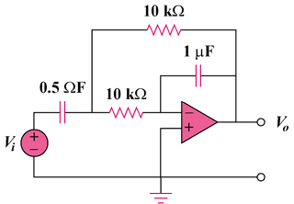

Figure 16.112
For Prob. 103.

